FIFTH GRADE SUPPLY LIST
1 BOTTLE OF HAND  SANITIZER  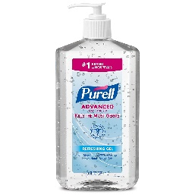 | 1 BOX COLORED  PENCILS  1 BOX OF CRAYONS  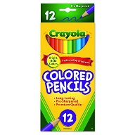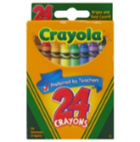 | 1 PACKAGE OF  NOTEBOOK  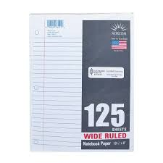 | 2 PACKS OF  BLACK DRY ERASE MARKERS  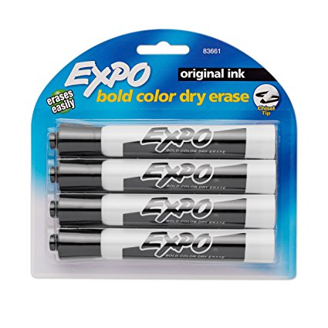 | 1  3-RING BINDER  
1- 2 POCKET  FOLDER  Solid color  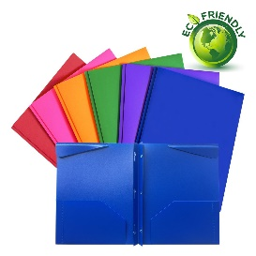 | 2 BIG PINK  ERASERS  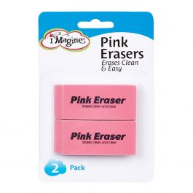 | A note from  Your 5TH Grade  Teachers  - Please Do Not  Label any  Supplies.  - If you are able;  Teachers are always able to  Use any extras  Of the supplies  Listed.  We look forward to seeing you next school  Year! | 4 SPIRAL NOTEBOOKS  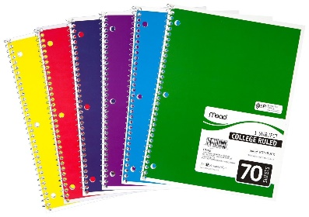 | 1 PACK OF  HIGHLIGHTERS  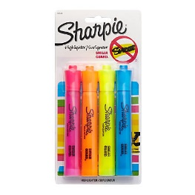
1 BOX OF  PENCILS  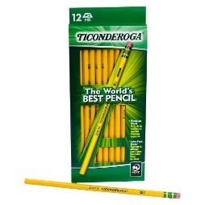 | 2  BOXES OF KLEENEX  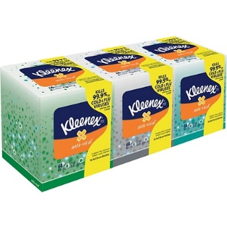 |  | 2 GLUE STICKS  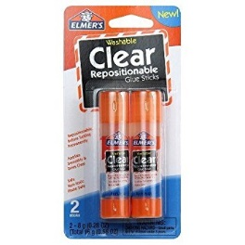 | 1 CONTAINERS  LYSOL/CLOROX  WIPES  